**Simon Kuznets Kharkiv National University of Economics**

DEPARTMENT OF INFORMATION SYSTEMS

**COMPLEX COURSE PROJECT: PROGRAMMING**

on the topic: "Development of a software product to work with a file database on the duration of calls of PBX subscribers"

2-year-student of the 6.04.121.010.18.3 Specialty 121 group of "Software Engineering" of the first (bachelor) level

Tereshkin M.S.

Head: Associate Professor of the Department of IS, Ph.D. tech. Associate Professor, Burdaev V.P.

National scale ____________________

Number of points: ______________________Score: ECTS ______________

Members of the commission

____________________ ______________________

(signature) (surname and initials)

____________________ ______________________

(signature) (surname and initials)

Kharkiv – 2020 year

**Content**

|  |  |
| --- | --- |
| Introduction | **3** |
| Formulation of the problem | **4** |
| Software Requirements | **5** |
| Architecture of the software system | **6** |
| Testing a software system | **7** |
| User Manual | **8** |
| Message to user | **11** |
| Findings | **12** |
| Conclusions | **14** |
| List of references | **15** |

**Introduction**

**Computer software**, or simply **software**, is a collection of [data](https://en.wikipedia.org/wiki/Data_(computing)) or [computer](https://en.wikipedia.org/wiki/Computer) instructions that tell the computer how to work. This is in contrast to [physical hardware](https://en.wikipedia.org/wiki/Computer_hardware), from which the system is built and actually performs the work. In [computer science](https://en.wikipedia.org/wiki/Computer_science) and [software engineering](https://en.wikipedia.org/wiki/Software_engineering), computer software is all [information](https://en.wikipedia.org/wiki/Information) processed by [computer systems](https://en.wikipedia.org/wiki/Computer_system), [programs](https://en.wikipedia.org/wiki/Computer_program) and [data](https://en.wikipedia.org/wiki/Data). Computer software includes [computer programs](https://en.wikipedia.org/wiki/Computer_program), [libraries](https://en.wikipedia.org/wiki/Library_(computing)) and related non-executable [data](https://en.wikipedia.org/wiki/Data_(computing)), such as [online documentation](https://en.wikipedia.org/wiki/Software_documentation) or [digital media](https://en.wikipedia.org/wiki/Digital_media). Computer hardware and software require each other and neither can be realistically used on its own.

Along with hardware and information resources, software is one of the components of a computer. Modern software is regularly updated and supplemented by developers to meet the latest technologies and delight users with more advanced functionality.

That is why it needs to be updated from time to time. The most striking example of software is software for a grocery store, combining many other programs. Software can also sometimes mean any program installed on a computer, but this is not entirely true.

To develop the application, the C# programming environment was chosen, which provides ample opportunities for co-designing software forms for various purposes.

**Formulation of the problem**

Development of a software product for working with the file database of calls of PBX subscribers , using C #.

The program should support the login and password and go to the main page.

The program should be implemented in Visual Studio 2017.

**Software Requirements**

The **user interface** (**UI**), in the [industrial design](https://en.wikipedia.org/wiki/Industrial_design) field of [human-computer interaction](https://en.wikipedia.org/wiki/Human%E2%80%93computer_interaction), is the space where interactions between humans and machines occur. The goal of this interaction is to allow effective operation and control of the machine from the human end, whilst the machine simultaneously feeds back information that aids the operators' [decision-making](https://en.wikipedia.org/wiki/Decision-making) process. Examples of this broad concept of user interfaces include the interactive aspects of computer [operating systems](https://en.wikipedia.org/wiki/Operating_system), hand [tools](https://en.wikipedia.org/wiki/Tools), [heavy machinery](https://en.wikipedia.org/wiki/Heavy_machinery) operator controls, and [process](https://en.wikipedia.org/wiki/Unit_operation) controls. The design considerations applicable when creating user interfaces are related to or involve such disciplines as [ergonomics](https://en.wikipedia.org/wiki/Ergonomics) and [psychology](https://en.wikipedia.org/wiki/Psychology).

Generally, the goal of [user interface design](https://en.wikipedia.org/wiki/User_interface_design) is to produce a user interface which makes it easy, efficient, and enjoyable (user-friendly) to operate a machine in the way which produces the desired result. This generally means that the operator needs to provide minimal input to achieve the desired output, and also that the machine minimizes undesired outputs to the human.

For the installation, Windows XP or higher required with installed .NET Framework 4.6;

**Hardware requirements:** 1. Processor - not lower than Pentium 2,266 MHz 2. Free disk space at least 124 MB 3. Available RAM space at least 128 MB Software requirements: 1. Operating system: • Windows XP - Windows 10 • Linux • Mac OS X 10.7.3 (Lion) and earlier • Solaris 10 and earlier 2.

**The architecture of the software package**

Forms are the building blocks of an interface. To create a well-designed form, it is necessary to understand its purpose, method and time of use, as well as its relationship with other elements of the program.

A special type of form is a form for entering data.

During their development, the main attention should be paid to the speed of their use.

The basic rule is that if the user is going to enter a large number of records into the database, then he does not have to confirm the entry of each of them.

**Testing a software system**

An example of a test plan combined with a test report.

Test example: # 1. Purpose: to check whether the software system can read button clicks and correctly display them in the graphical user interface. Prerequisites for the test: The software system must be running, and there must be a data file in a specific format on the computer disk. Test Criterion: The actual behavior of the software system is the same as expected.

In the panel, select the file name of the specified format and click the "Info" button. In the main window, the programs that downloaded the file should display correctly. Data downloaded from a file is displayed correctly in the main application window.

**User’s manual**

Purpose of the Software product.

The desktop app that was developed is intended for using by PBX companies. It surely eases tracking and storing data about subscribers, tariffs etc.

So, in order to enter the system, you will need credentials of account with correspondent to your position role. Please, contact administrator if you don’t have those.

Starting the program.

The program is launched under the Windows operating system in one of standard ways:

1. Double-click the shortcut of the application;
2. Calling the context menu;

User Login

After starting the program, the “Login” window appears (Fig. 1). There you should enter your user name and password.

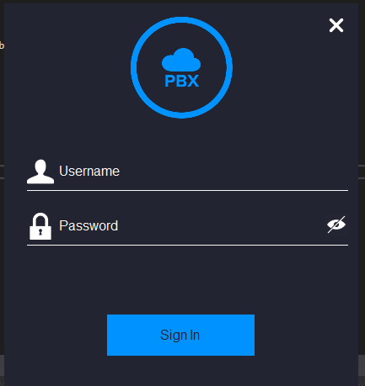

Fig. 1

After that, press “Sign in” button and if your credentials are correct, you will see the main window (Fig. 2) with data storing and editing logic.

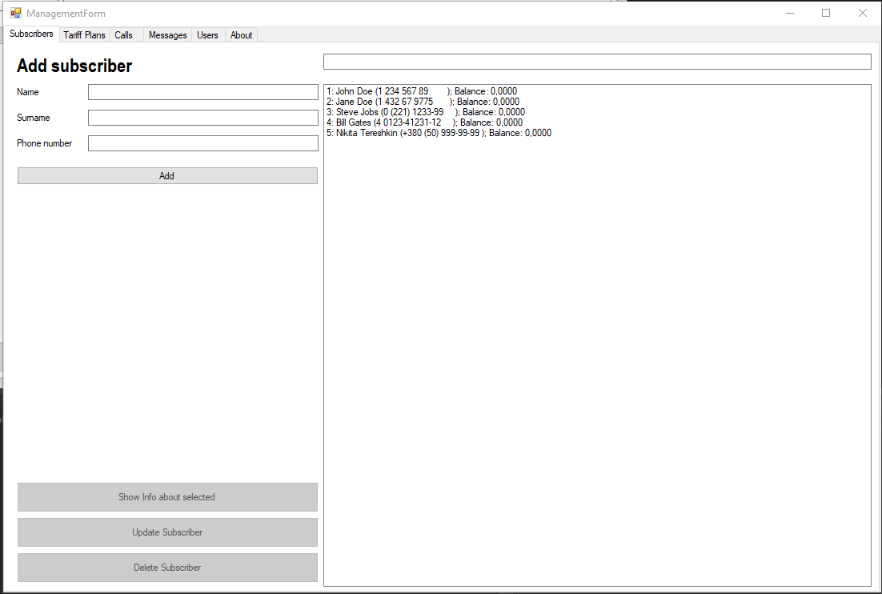

Fig. 2

The main window has tab structure. It means that we can see some tabs (“Subscribers”, “Tariff Plans”, “About” etc.) and by clicking on one of them, you could go to the administration controls of the correspondent table in the database.

On the top of the window you could see some fields and button for Adding, Search field where you could just start to typing your request, and it will automatically show all the coincides we have in database table.

By clicking on one of the records in the main list box, you unlock “Info”, “Update” and “Delete” buttons at the bottom of form. It means you are able to do those operations with the record you selected.

For example, if you click “Update” button, you will see the new window with fields for editing some data (Fig. 3).

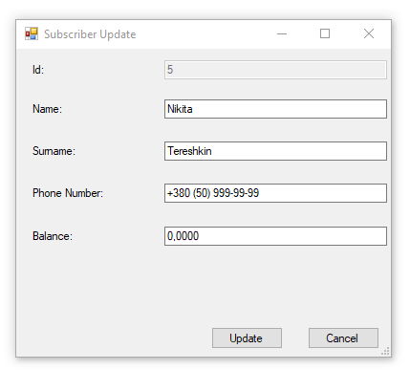

Fig. 3

In order to save new values, just click “Update” button.

**Message to user**

The user sees the login window when the program starts, then he must enter the login and password, if the login or password is not entered correctly, the program will give the user a warning window (Fig. 4).

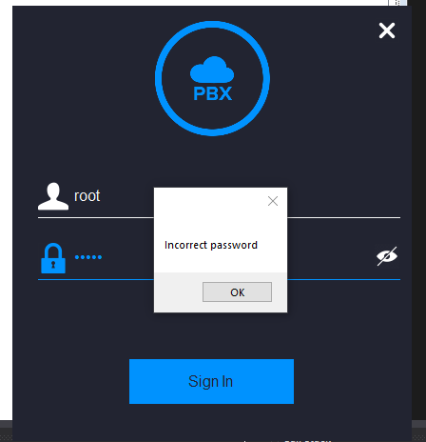

Fig. 4

**Findings**

The class diagram:

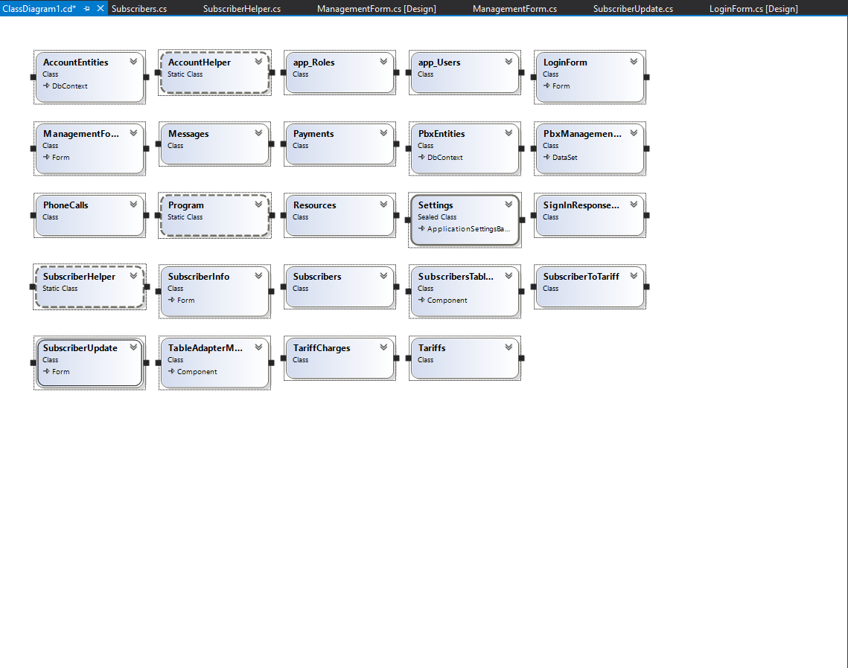

The database tables diagram:

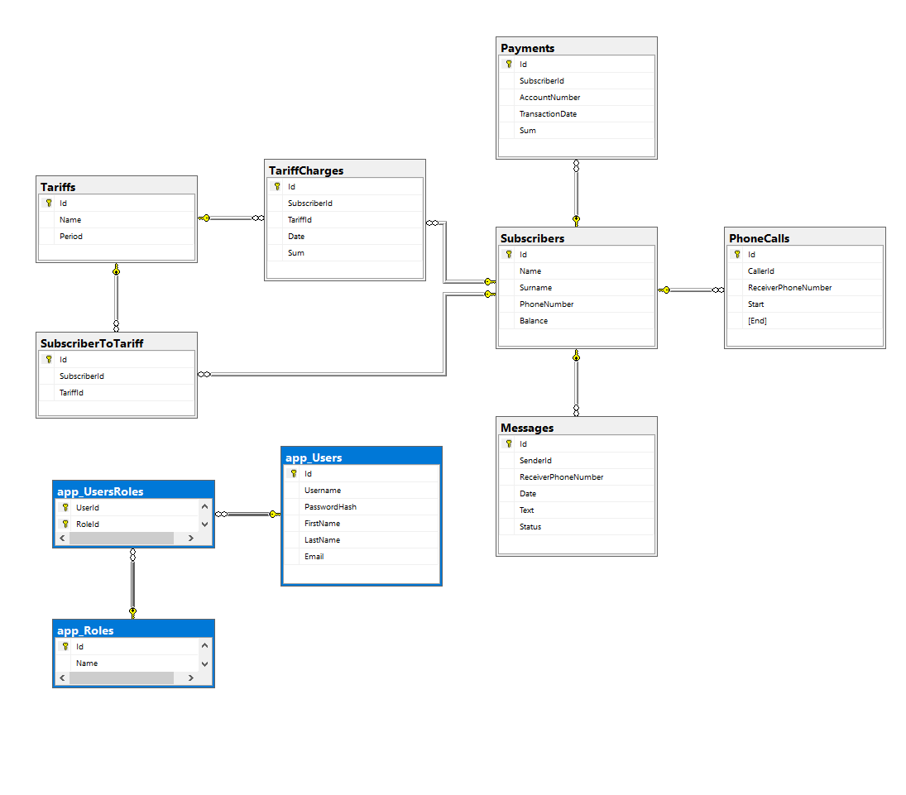

The solution structure:

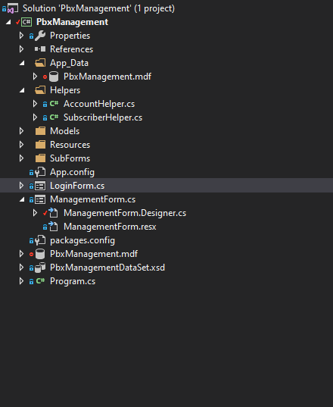

**Conclusions**

Developed in this course work, the application is a software product and can be used on its own or as a component of another information system.

The program is focused on the average user who does not have special knowledge in the field of information technology and programming.

The module is easy to install, and in the absence of one or two of the dependency modules at once, the system will function within the available capabilities without leading to critical errors and the failure of the site running C #.

In accordance with the concept of code reuse, which is one of the foundations of the Open Source ideology, the module logic is based on the previously existing - well-functioning and time-tested functionality of the other two modules, harmoniously interacting with it - thereby expanding the capabilities of the user and the webmaster in general in particular in the field of convenient and understandable organization of content on the site.

At this stage of development, the module’s functionality is logically completed. In the case of continued development in the direction of expanding the functionality, you should add the possibility of a greater redefinition of the initial settings by the site administrator, and it is also possible to abandon the Reference module due to the expected termination of its support. In this case, you should independently implement all the functionality of the field used for the backlink.

**List of links**

* <https://www.cyberforum.ru/windows-forms/thread248710.html>
* <http://mycsharp.ru/post/42/2014_03_26_regulyarnye_vyrazheniya_v_si-sharp_klass_regex.html>
* <http://www.codenet.ru/progr/cpp/csharp.php>
* <https://www.videosharp.info/article/sharp/id=494>
* <https://ru.wikipedia.org/wiki/C_Sharp>  
  <https://metanit.com/sharp/windowsforms/2.1.php>
* <https://c-sharp.pro/?p=914>
* <https://www.videosharp.info/article/sharp/id=494>
* <https://programmersforum.ru/showthread.php?t=296305>
* <https://docs.microsoft.com/en-us/dotnet/csharp/tour-of-csharp/>
* <https://docs.microsoft.com/en-us/dotnet/csharp/>
* <https://viduus.net/wp-content/uploads/2018/02/Rihter-Dzh.-CLR-via-C.-Programmirovanie-na-platforme-Microsoft-.NET-Framework-4.5-na-yazyke-C-Master-klass-2013.pdf>